Experiment No.: 9
Title: Access and Validate Form Using Events – Design a Gym Admission Form with Live Input Checks
Software/Tools Required: HTML5, CSS3, JavaScript, VS Code, Google Chrome
Theory: In JavaScript, form events such as input, change, blur, and submit are used to access and validate user input in real time. When a user types in a field, the input event fires, allowing immediate validation. For radio buttons, checkboxes, and dropdowns, the change event is used. The blur event validates a field when the user leaves it.Form validation ensures that data entered by the user follows specific rules, such as required fields, correct email format, valid mobile number, password strength, and matching passwords. By using JavaScript with DOM manipulation, we can display error or success messages dynamically and enable or disable the submit button based on overall validity. The submit event is used to prevent the default page reload and process the form only when all fields are valid.A gym admission form requires details like full name, email, mobile number, date of birth, gender, membership plan, password, address, and terms acceptance. Live input checks improve user experience by giving instant feedback and reducing invalid submissions
Output:
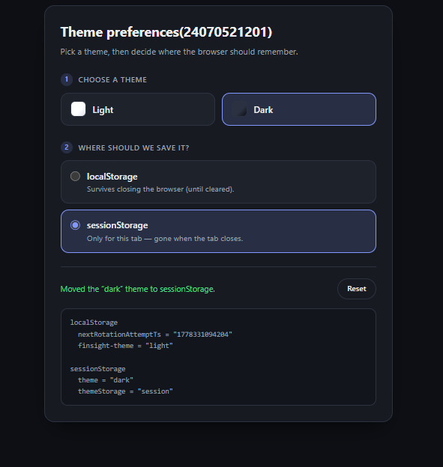

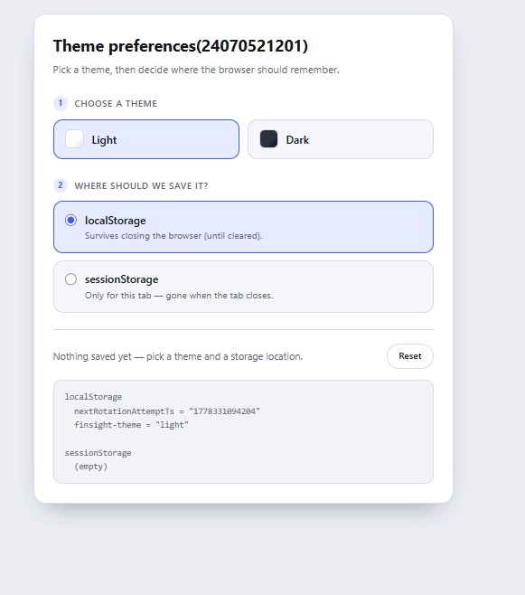

Result: User preferences such as theme settings were successfully stored, retrieved, and managed using JavaScript localStorage and sessionStorage.
Conclusion: Thus, localStorage and sessionStorage can be effectively used in JavaScript to store and manage user preferences, improving the personalized and consistent user experience of web applications.

